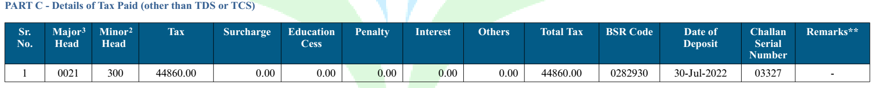

Bank Statement

|  |  |  |  |  |  |
| --- | --- | --- | --- | --- | --- |
| ***Post Date*** | ***Value Date*** | ***Branch Code*** | ***Cheque Number*** | ***Account Description*** | ***Debit*** |
| 30/07/2022 | 30/07/2022 | 08103 |  | TO TRANSFER/DIRECT TAX ITNS280:03327 | 44860.00 |